**User Guide**

User guide provides instructions on how to use iLearnCentral application and how to navigate and operate the app.

Log in Page – This is where the user of the application needs to input their credentials in order to use the application.

Tap Forgot Password if you have forgotten your password and wait for an email to reset it

Tap Sign Up if you’re a new user

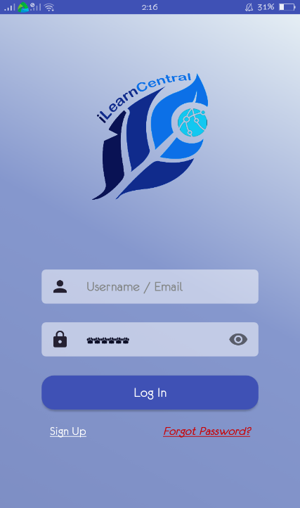

Input username or a valid email and password if you already have an existing account in the application. Then after inputting tap Log In.

Figure 43: **Log In Page**

Account Type Selection Page – This is where the new user of the application gets to choose the type of account type he’ll be using in the application.

After clicking Sign Up, the user may choose which account type he’ll be using. He just needs to tap from one of these and choose what type of account he’s signing up for, whether it is Learning Center account, an Educator account or a Student account.

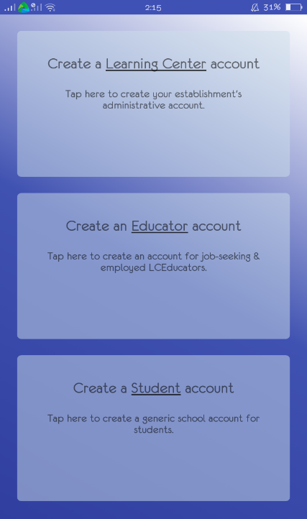

Figure 44: **Account Type Selection Page**

Sign- Up Page – This shows the different Sign Up page for the different type of users of the application. It is where the specific information needed for each account should be provided in order to make the account.

Learning Center Sign up Form

Input all the information needed such as business name, the website of the learning center, the email address and active contact number they’re using where the students may contact them, a small description about the learning center and lastly the address

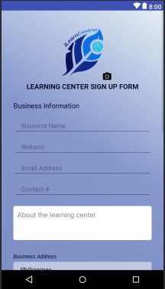

Educator Sign up Form

Input all the information needed such as the educator’s first name, middle name, last name, his marital status, gender, birth date, citizenship, religion and his home address

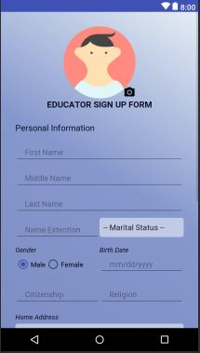

User Sign up Form

Input all the information needed such as the username, password, valid email address and contact number and lastly choose a security question to secure the account.

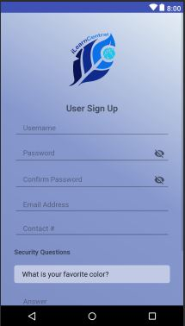

Figure 45: **Sign Up Page**

Learning Center User Interface- This shows the profile of the learning center, its information about, feed or posts about existing learning centers, job posting from the learning centers, enrollment where subjects are posted, educators page where educators information are can be seen, classes page where subjects and its corresponding educators are presented with the complete details like the schedule for the class. A search button at the top where the user can search anyone that uses tha application, an enrollment button, a notification bell to notify the user of any activity or action and the messages.

Learning Center Profile Page

Notification button where the user will be notified whatever activity or action

Enrolment button for the user to choose what subjects to enroll from a certain learning center

Search button where the user can search anyone that’s registered to the application whether it is a Learning Center User or an Educator

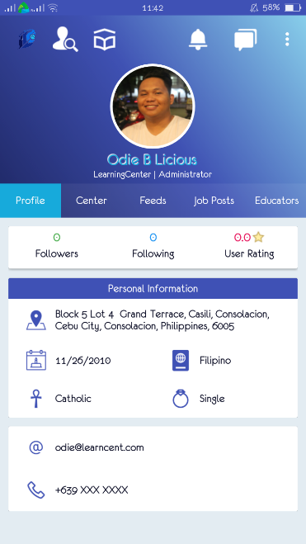

Shows the personal information about the learning center which includes the number of followers of the center, the number of how many accounts the center has been following and lastly the ratings of the center

Learning Center About Center Page

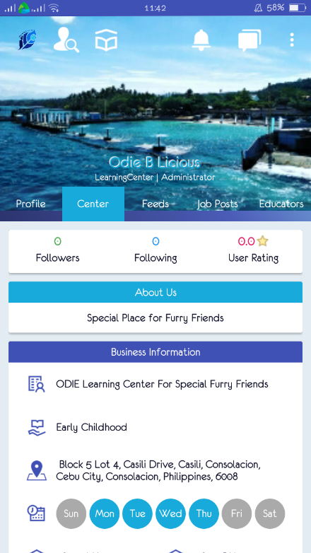

Shows the business information about the learning center which includes the name, business information, its address and their business schedule

Learning Center Feed Page

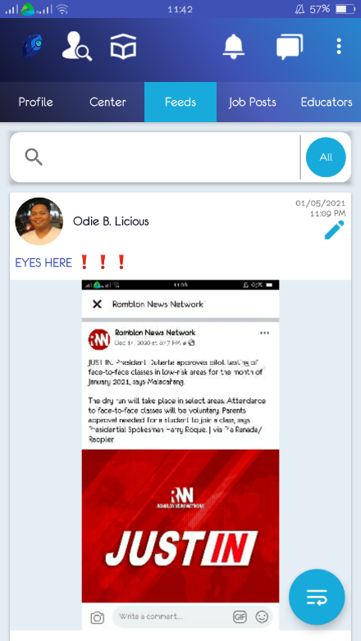

Shows the feed or posts from the different existing learning centers from the application.

User may also input in the search bar of any topic he wants to look for that may already be posted from other learning centers

Learning Job Posts Page

Shows the job postings from different learning centers

User may also input in the search bar of any job types from different learning centers

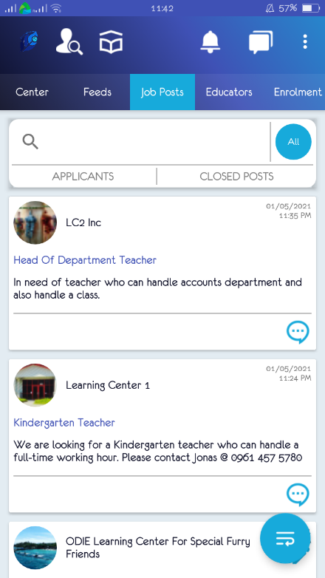

Learning Center Enrollment Page

This is where subjects are posted together with the corresponding schedule to which students will be able to choose for them to enroll

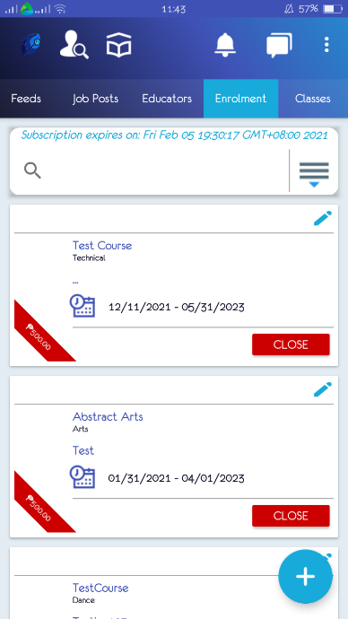

Learning Center Educators Page

This will show all the employed educators of that certain Learning Center user, where status and information of an educator can be seen

User may input a name an educator, their status or any certain information and results will be shown below depending from the searched keyword inputted in the search bar

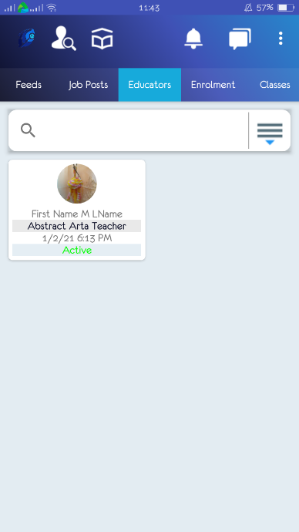

Learning Center Classes Page

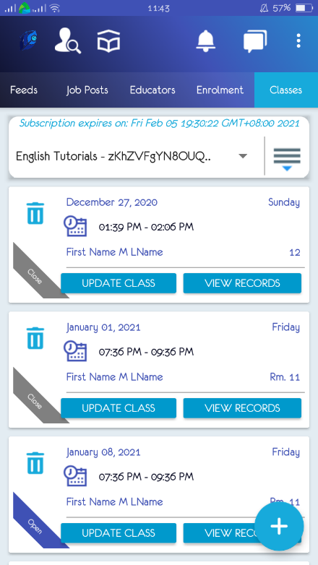

All the classes with the subjects with its corresponding educators will be shown in this part of the classes page

Learning Center Enrollment and Scheduling Subscription Page

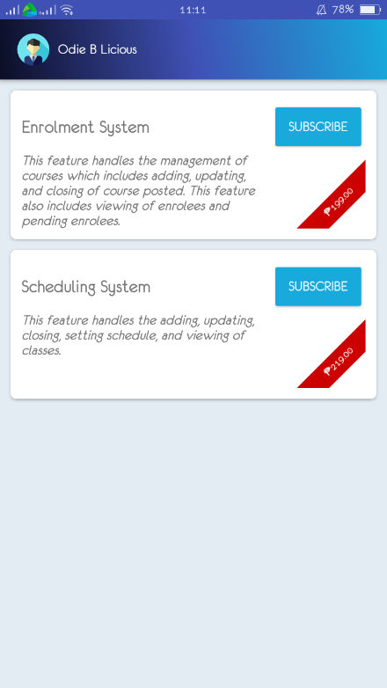

Users may tap subscribe to in order to avail other services the system offers such as adding, updating, and closing of course posted, also the viewing of the overall enrollees and the pending enrollees and the scheduling system which includes adding, updating, and setting schedule of classes

Learning Center Search Page

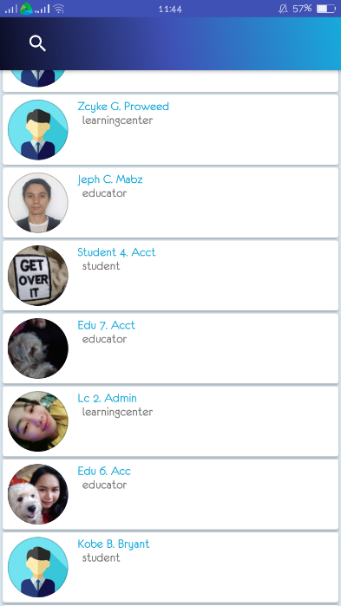

Search button where the user can search anyone who is registered to the application whether it is a Learning Center User or an Educator

Learning Center Recommended Learning Center Page

Users may input names or keywords that will result to the Learning Center they’re interested in to

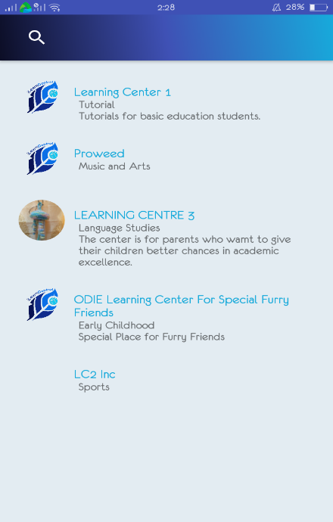

Learning Center samples will be shown here based from the keywords or names searched from the search bar above

Learning Center Sidenav Page

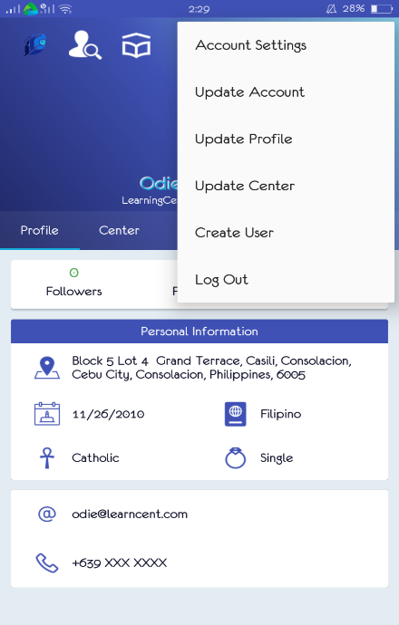

Other options of what the user wanted to do to his account on the system are visible in this part of the page, he may go to the settings account to change anything he wanted, update his account or profile, update the center or create a new user and lastly if the user’s done using with the system, just click Log out

Figure 46: **Learning Center User Interface**

Educator User Interface - This shows the educators profile page, its information about or feed from the different learning centers or educators, the job posting where details such as job name or job description can be seen and to where or what learning center it is from, the educator’s classes page where the subjects and its scheduled time and day can be seen and lastly the search bar and the message button where an educator may send message to anyone and may able to received a message to whoever is authorized for them to message to.

Educator Profile Page

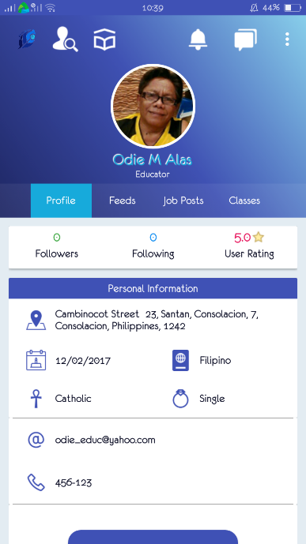

Shows the personal information about the educator which includes the number of followers of the educator, the number of how many accounts the educator has been following and lastly the ratings of him as an educator. This is where the educator user can edit its information, in his profile where his personal information is can be seen, like his address, birth date, religion, citizenship, marital status, email address, contact number and educational background. His status may also be seen whether he is already employed to a certain learning center

Search button where the user can search anyone that’s registered to the application whether it is a Learning Center User or an Educator

Enrolment button for the user to choose what subjects to enroll from a certain learning center

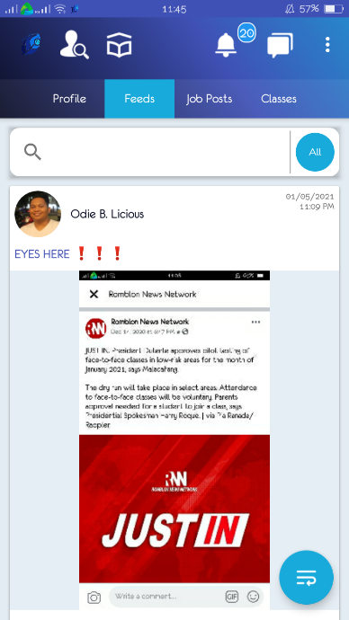Educator Information Feeds Page

Educator users will be able to view any updates from the different learning centers or from its fellow educators from his feeds page

Educator Job Posting Page

Different job posting from the learning centers can be viewed by the educators registered in the application from here

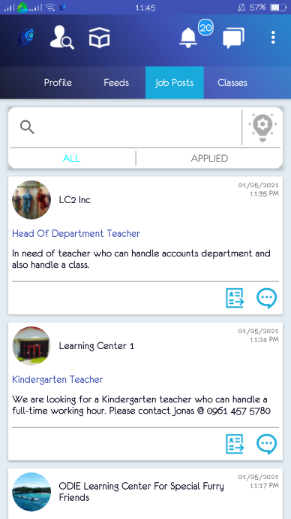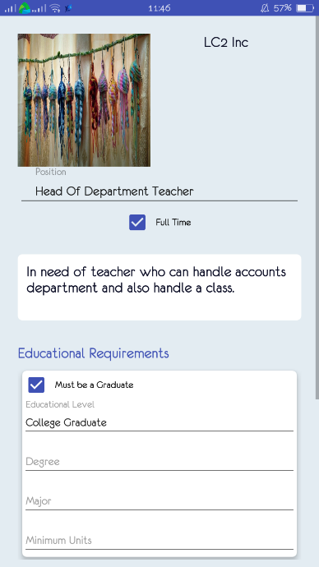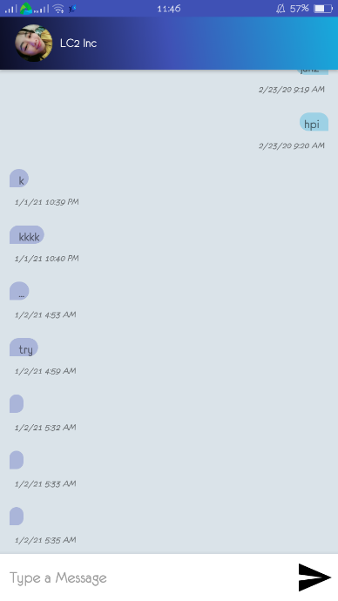

User may also contact the employer of the said job just by sending them a message

Educator Classes Page

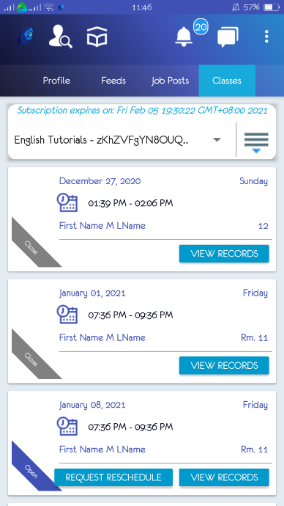

All the classes by the educator user will be shown here with its corresponding details such as the subject’s name and its time and days it is scheduled.

Educator Search Page

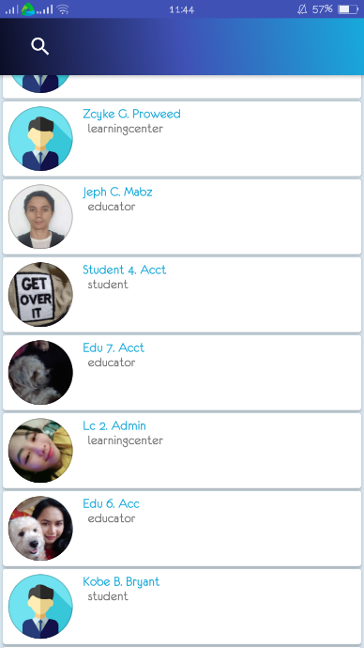

Search button where the user can search anyone that’s registered to the application whether it is an Educator or a Learning Center

Sample registered users of the application shown by the system

Educator Learning Center Page

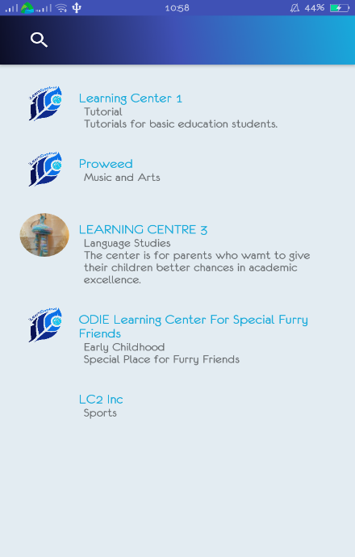

Educator user may also view different learning centers with its complete name, location, description and all the necessary details

Educator Message Page

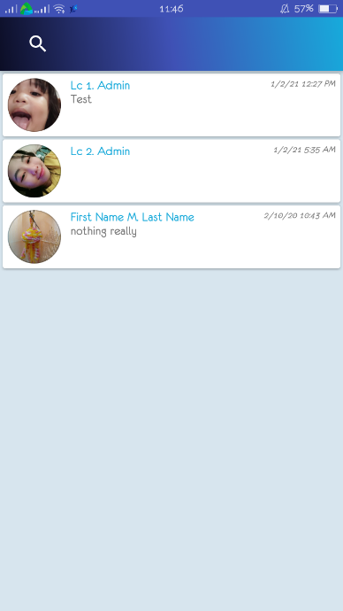

Educator user may send messages to all members that are only authorized for them to send a message to

Figure 47: **Educator User Interface**

Student or Parent User Interface - This shows the profile of the student or the parent, its information feed or posts about existing learning centers or edcators , the courses page , the classes page where different classes from different educators or learning centers are posted. A search button at the top is also visible where the user can search anyone that’s registered in the system and lastly the recommended learning centers for the student or parents cant also be viewed.

Student or Parent Profile Page

Shows the personal information about the student or parent which includes the number of followers of the student or parent, the number of how many accounts the student or parent has been following and lastly the ratings of him as a user. This is where the student or parent user can edit its information, in his profile where his personal information is can be seen, like his address, birth date, religion, citizenship, marital status, email address and contact number

Message button where user can see any messages, may it be from the learning center an educator or another student

Search button where the user can search anyone that’s registered to the application whether it is a Learning Center User or an Educator

Notification button where the user will be notified whatever activity or action

Enrolment button for the user to choose what subjects to enroll from a certain learning center

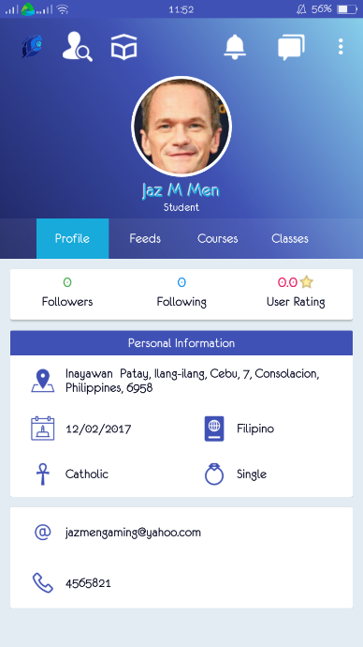

Student or Parent Information Page

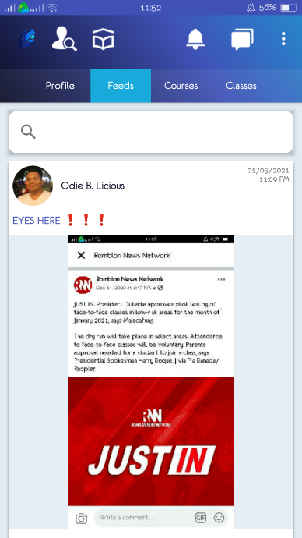

Information feed that will show other posts by other students or parents they are updated or anybody they’re following

Student or Parent Courses Page

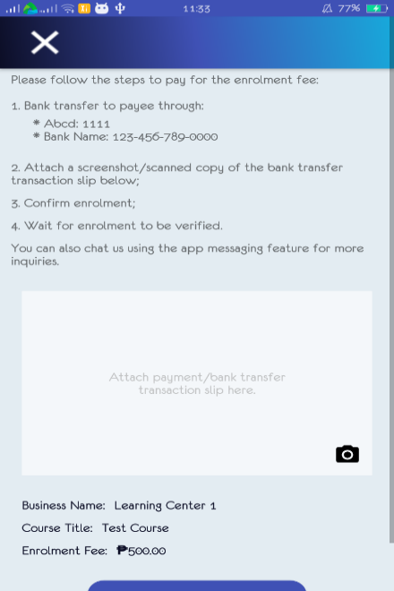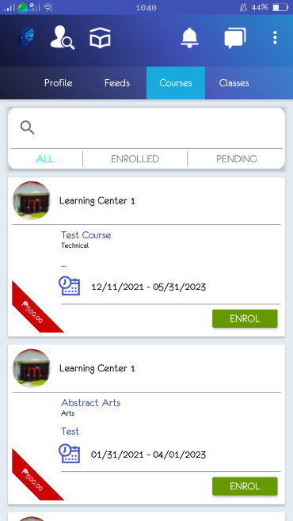

Student user will tap enroll if he wanted to take the course

This is where the Student user may view all the courses that’s intended for them to enroll or that’s instructed by the learning center

Student or Parent Classes Page

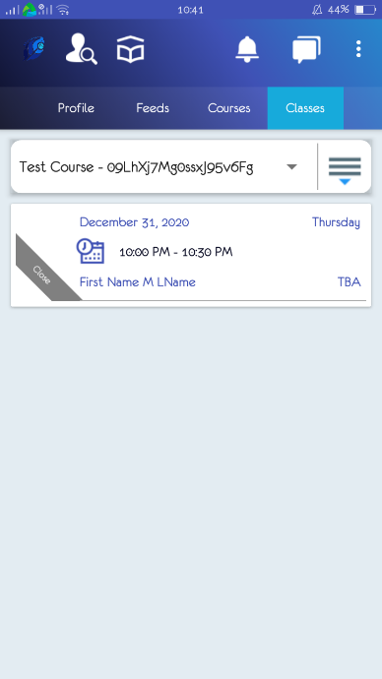

This is where the Student user can view all of its classes throughout the day. Information such as the subject name and the schedule of each subjects are shown

Student or Parent Search Page



Search button where the user can search anyone that’s registered to the application whether it is a Learning Center User or an Educator

Student or Parent Recommended Learning Centers

Users may input names or keywords that will result to the Learning Center they’re interested in to



Learning Center samples in which the user can view all the information he wants to know

Student or Parent Recommended Messages

Users may input names or keywords that will result to the users existing in the application



They can create a message to/from the users they may wish to have a conversation with

Figure 48: **Student User Interface**